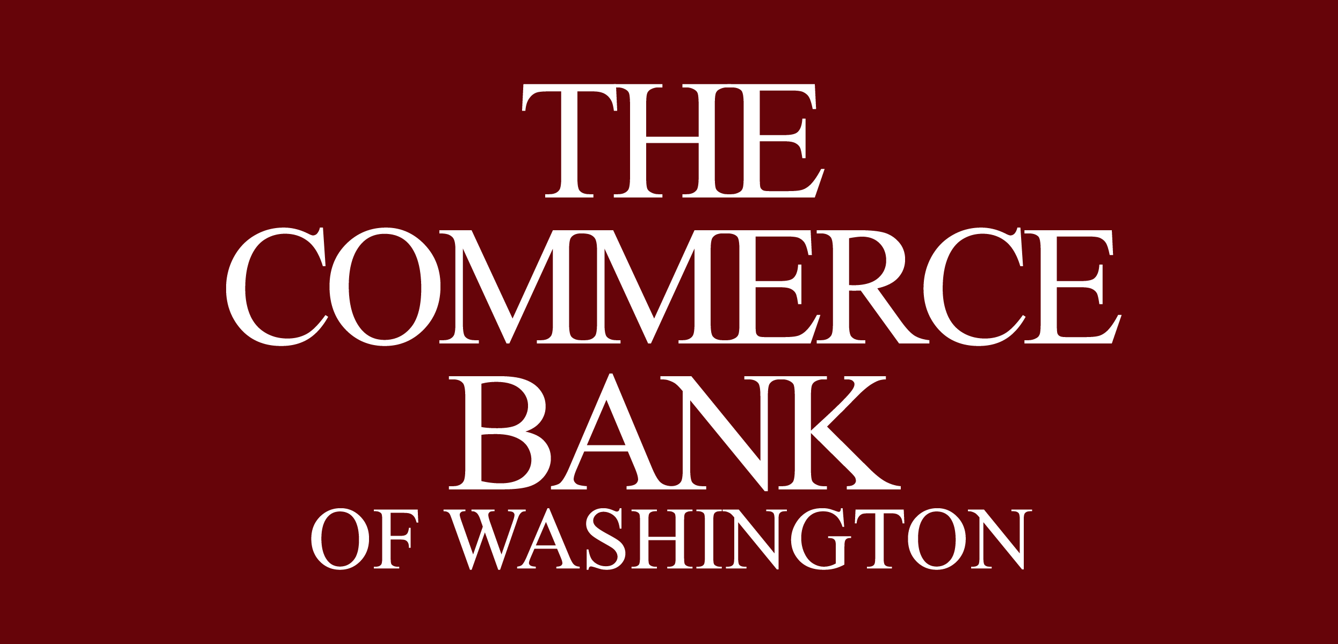
Subject: Important: Notice of Change to Commercial Credit Card Master Agreement

This notice is to inform you of an upcoming change to the Commercial Credit Card Master Agreement governing your Card Account(s).

Summary

- Section 6 – “Term” of the Commercial Credit Card Master Agreement is deleted in its entirety and replaced with the italicized language below.
- The Agreement will have an initial term of three (3) years from the date of execution.
- After the Initial Term, the Agreement will automatically renews for successive one-year renewal terms unless either party provides at least 90 days’ written notice before the current term ends.
- Any party may terminate the agreement at any time for convenience by providing 90 days’ prior written notice.
- Any transactions or obligations already in existence at the time of termination – including contingent or unmatured obligations remain enforceable under this agreement and the Cardholder Agreement.
- If fewer than all participating companies terminate, the bank chooses to terminate the agreement for the remaining companies as well. Any new company joining later will only join for the remaining portion of the current initial or renewal term already in effect.
- Section 10 – “Changes” of the Commercial Credit Card Master Agreement is deleted in its entirety and replaced with the italicized language below.
- The Bank may occasionally amend the Agreement by providing written notice.
- If you do not agree with a change, you must notify the Bank in writing within 25 days after the change becomes effective.
- If you reject a change, the Bank may close the affected Card Account and require payment of the outstanding balance in accordance with the Agreement.
- Continued use of the Card after the effective date of a change constitutes acceptance of the revised terms.

Change to Section 6 – “Term”
Effective immediately, Section 6 (“Term”) of the Commercial Credit Card Master Agreement will be replaced in its entirety with the following revised language.

Changing this Agreement
This Agreement shall have an initial term (the "Initial Term") of three years beginning on the date hereof, and shall renew automatically for successive one-year terms (each a "Renewal Term") unless written notice of termination is given by a party at least 90 days prior to the end of the Initial Term or any Renewal Term. In addition, any party may terminate this Agreement for convenience at any time upon 90 days’ prior written notice. Any Transactions and other obligations already existing, even if contingent or unmatured at the time of termination, shall remain owing and governed by this Agreement and the Cardholder Agreement. In the event of termination by fewer than all of the undersigned Companies, Bank may in its discretion choose to terminate this Agreement as to the remainder of the individual Companies, but such termination of the Agreement shall be deemed termination by the Companies.

Any future joinder by an additional Company shall be for the remainder of the Initial Term or Renewal Term already in effect.

Change to Section 10 – “Changes”
Effective immediately, Section 10 (“Changes”) of the Commercial Credit Card Master Agreement will be replaced in its entirety with the following revised language.

Changing this Agreement
Account Holder agrees that the Bank may change the terms of this Agreement, including without limitation any term pertaining to interest charges. The Bank will notify Account Holder of any such change as required by applicable law. If Account Holder does not agree to the change, Account Holder must notify the Bank in writing within twenty-five (25) days after the effective date of the change, and the Bank may close the Card Account and may elect to require Account Holder to pay the Outstanding Balance on or before the payment due date. Otherwise, Account Holder shall be deemed to have agreed to the change described in the Bank’s notice. Use of the Card after the effective date of the change shall constitute Account Holder’s acceptance of the new terms.

All other terms of the Commercial Credit Card Master Agreement remain unchanged. Please contact us if you have any questions regarding this notice.

Cash Management Operations
(206) 292-4550

